Press Here for More Data

Advanced Tracking with Simple Technology
Sarah Leonard-Hayward
United States Military Academy Library
1/13/2025

Intro
The views presented here are those of the author and do not necessarily represent the views of the U.S. Military Academy, U.S. Army, or the Department of Defense. References to any specific commercial product, process, or service, or the use of any trade, firm or corporation name is for the information and convenience of the public, and does not constitute endorsement, recommendation, or favoring by the Department of the Defense, the United States Army, or the U.S. Military Academy.
Many public-facing librarians have encountered the time-honored tradition of putting a hash mark to paper after an encounter with a patron at a service point. While many libraries have moved to electronic forms of data gathering, this method has not necessarily been upgraded to meet the latest technology available. Common pitfalls arise from the limited data collected with hash marks. Each interaction is counted, but none of the important details about the interactions are captured.
The United States Military Academy (USMA) is an undergraduate institution with a population of about 650 teaching faculty and 4,393 students, known as Cadets, who are active-duty military personnel. The United States Military Academy Library (USMA Library) is made up of 38 staff, 22 of which are Librarians, and there are no student employees. The USMA Library has three service desks; the Front Desk, which is the primary checkout desk, the Help Desk which is used for reference services, and the Archives and Special Collections desk which is housed in a separate building. The Front Desk is staffed 100.25 hours per week, the Help Desk is staffed 78 hours per week, and the Archives and Special Collections desk is staffed 38 hours per week. With 216.25 hours of staff time being spent at service desks each week, it was imperative to collect accurate data about this significant expenditure. The USMA Library had to contend with staffing reductions between 2023 and 2024, consider the impacts of Generative AI, and address the fact that previous methods were ineffectual for capturing the full picture of what happened at service desks.
The solution for the USMA Library was to implement Stream Decks, programmable button hardware systems, as tools. These button systems are used to collect more detailed and accurate reporting at service points while mitigating difficulties like staffing constraints and ensuring patron experience is not interrupted by reporting activities. With the push of a button, date, time, location, question type, question method, patron type, and staff member who answered are all recorded automatically. USMA Library uses the software RefAnalytics in Springshare to record this data in an accessible and editable format.

Literature Review
The motivations for libraries to collect statistics are “to support administrative decisions, describe library activities, and to establish general principles and relationships concerning library organizations, administration, and use.” Over the years there have been several studies related to the collection of library usage statistics. The earliest studies didn’t take into account the interactions between patrons and library staff. Per Lawrence Thompson 1951 in The Library Quarterly, “Most library reports prior to 1900 offer little assistance to the student of library history who seeks statistical information.” Usually, collected data prior to the 1900s was the number of patrons and the number of books lent and the size of the collection. The earliest discussion about statistics as we would recognize them today started later in the 20th century.
Balay and Andrew 1975 explained, “Reference questions had simply been recorded by entering marks on a sheet that had been recorded by entering marks on a sheet…” Rather than simply marking what occurred, there was an interest in gathering information on the date, time, patron information and inquiry type. While the data points increased, allowing library professionals to evaluate and better support user inquiries, the systems for tracking this data were still incredibly time intensive, requiring library staff to fill out interview forms for each transaction. Then the forms were collected and provided to a key punch operator who would translate the information into Hollerith cards that could be compiled in a computer system. The data from the forms could then be queried to provide statistical information about the use of reference services. This system was revolutionary, but costly, requiring a great deal of staff time and specific positions for key punch operators and outsourced work from the Yale Computer Center.
In Mosborg’s 1980 study; to simplify the work of tracking interactions, other libraries chose to do random sampling. At the library at Indiana University at Urbana-Champaign, staff wore tags that they would fill out whenever an alarm sounded. This data was then transferred onto daily logs monitored by supervisors. This system still required hiring a research assistant to process the data and act as a key punch operator.
With the onset of the digital age, librarians have been able to adapt technologies to simplify these systems. For example, automation has been leveraged for the recording of data, causing key punch operators to be obsolete. Adding new forms of technology to provide reference services, including online chat, phone, and virtual services creates new facets that need to be included in data tracking to provide a complete picture of the services offered by a library. Online forms, like those Springshare offers via LibAnswers, allowed Western Washington University to track this data across various service desks in one form.
Additionally, spurred on by the internet and technology, many libraries have moved to a triage-reference services model. This means that paraprofessionals or student employees are often relied upon to provide tracking information about activities at various service points. Simplifying the method of collecting service point data is paramount to ensuring stable records that can be used for decision-making.

Design and Methodology
With technological advances, the library professions have seen development over time from hash marks and Hollerith cards to web forms, and now programmable button systems. From the mid-1990s onwards, the goal of data collection at libraries has always been focused on basic tenets,
- low-cost solutions
- simple systems for collection of data, both for instruction of staff, and ease of use.
- records needed to contain enough data points that various variables could be compared to each other.&
At the USMA Library, considerations included these important factors. During a discussion between staff, issues with the effort and time involved in reporting interactions at our service desks, why couldn’t tracking this data be as simple as just pushing a button?
This one thought changed the USMA Library’s trajectory. The issue wasn’t staff effort, better instruction, or expressing the value of the data that needed to be recorded. The USMA Library staff was well versed in all these things. The issue was that the system for recording data needed to be adjusted to fit the needs of our users, the users being the USMA Library staff.
Data collection at the service points at the USMA Library in 2022 was done through a survey-style form. During an interaction, library staff would input data manually while also serving patrons at the service points.
The data points at the USMA Library can be seen in Figure 1 which displays a sample of the survey the USMA Library staff filled out after each interaction. The data points in the survey included:
- Date of the interaction – an open text field
- Time the interaction occurred – an open text field.
- Name of the library staff member who answered the question – a multiple-choice question including a drop-down menu with USMA Library staff names listed.
- Category of the person asking the question – a multiple-choice question including a drop-down menu including the options: Cadet, Faculty/Staff, and Visitor/Other
- What mode of communication was used for the request – a multiple-choice question including a drop-down menu with information including both the type of technology used and/or which service desk a patron was at?
- What type of question was asked – a multiple-choice question including a drop-down menu including various categories designed to fit the USMA Library’s unique reporting needs.

Fig 1.
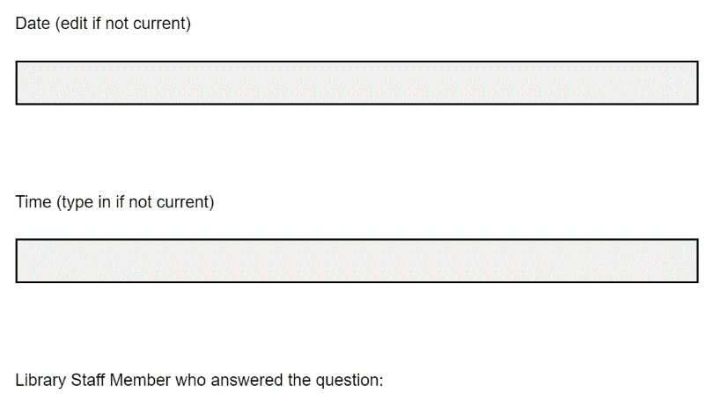
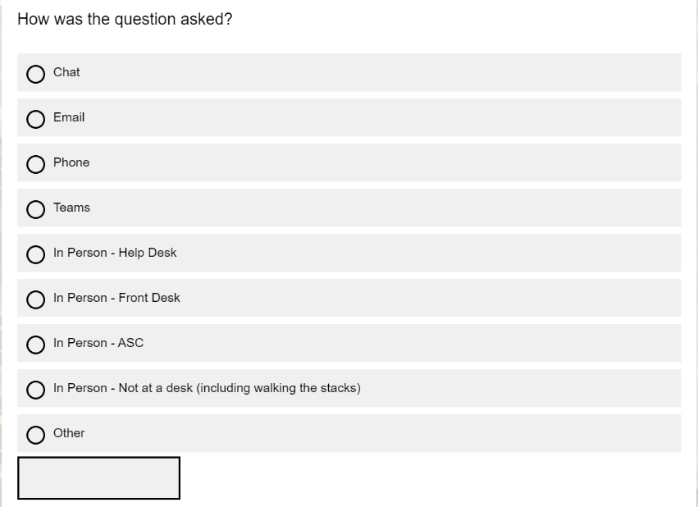
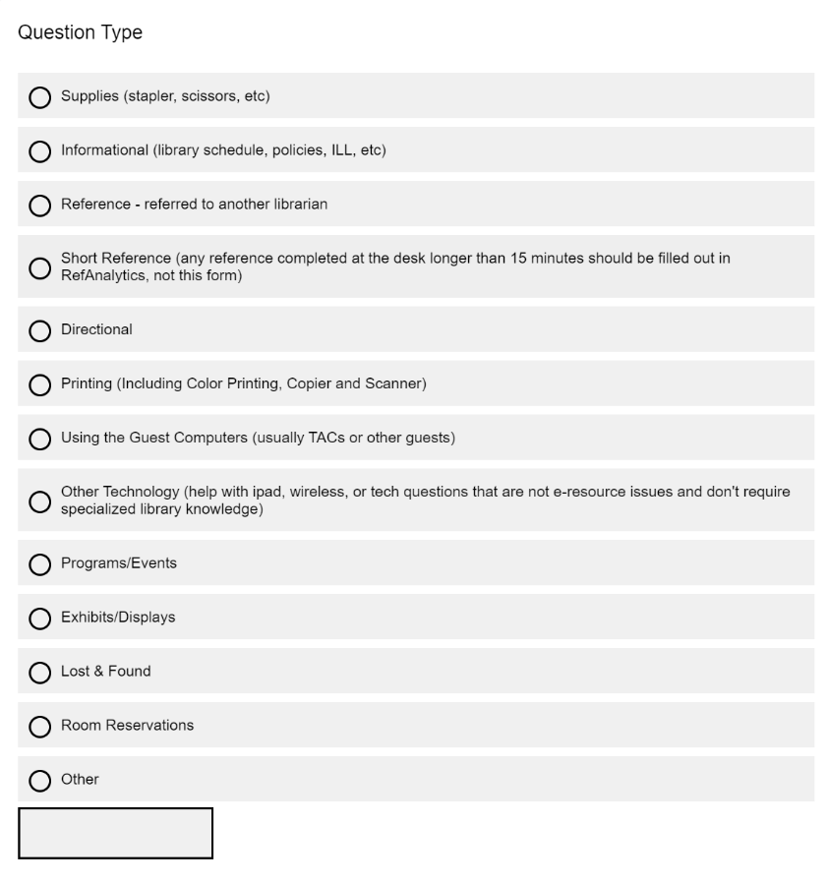
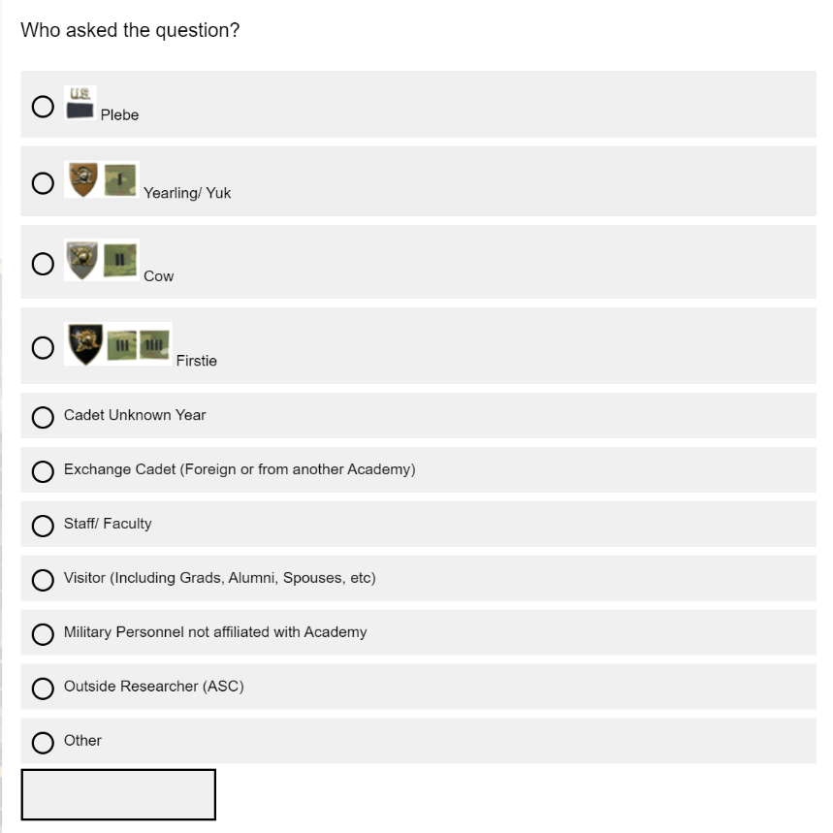
While the data collected was valuable, it was not complete. The type of question did not express the level of effort library staff needed to provide to answer the request. Additionally, we needed a way to record the amount of time each request was taking. The biggest hurdle for the USMA Library was ensuring the collection of more complete data. The busier a service point became, the more likely that record of the interaction would not be recorded. USMA Library staff needed a less disruptive and more efficient method for tracking these data points. Like the teams at Yale University in 1975 and University of Illinois at Urbana-Champaign in 1980, the USMA Library needed to refine its system of collecting data, ensuring data requirements were met without adding more work to staff members at our various service points.
In 2023 the USMA Library began planning and designing a push-button system for tracking these data points. Adapting the usage of individual streaming technology, we introduced Stream Decks, an LCD button deck that allows for the automation of specific tasks to be coded in apps or platforms. Combining this system with RefAnalytics or data collection software, the USMA Library updated the system for recording detailed transactions in a stable, effective, and informative manner.
Designing the button system required an understanding of what would be feasible for staff to use and what could be automated. As in the Western Washington University study, the goal was to design and implement the smallest number of categories and terms without losing out on valuable information. The Date, Time, and Name of library staff member could all be recorded automatically, while other important data points could be recorded based on the button that was associated with the specific interaction data. This required distilling the options under each question category seen in Figure 1.
The various questions had to be evaluated along with the response rate for each option. For “Who asked the question?” previous years of data were referenced, the most common choice under the Cadet heading was Cadet Unknown Year. The options for Plebe, Yearling/Yuk, Cow, Firstie, and Exchange Cadet were not reported in any meaningful way, additionally USMA Library staff realized that the data was not actionable. For these reasons, the options were combined into a single option, Cadet. Alternatively, the option for Staff/Faculty was considered appropriate for the new format. Finally, it was important to be aware that many visitors come to the USMA Library, but again USMA Library staff realized that the detailed data about the type of visitor was not actionable. It was decided to subsume any person who was not a Cadet or a Faculty/Staff member into a single grouping titled Visitor/ Other.
To simplify reporting, the question “How was the question asked?” was changed to a semi-automated data point, The USMA Library purchased three Stream Decks, one for each service point, which were set to record the name of the service point they were located at (Front Desk, Help Desk, or Archives & Special Collections). This location-based recording removed a step from the staff submissions and allowed the USMA Library to create options for the various buttons based on just two defining characteristics; “Who asked the question?” and “Question type.”
The options under Question Type required the most discussion and distillation to simplify USMA Library records. Decisions for categories were based on annual reporting requirements to the Army Library Trends and Statistics and the Association of College and Research Libraries (ACRL) who are a subset of the American Library Association (ALA); both of which require data about the number of reference transactions library staff complete. Reference was made a single category with parameters defined by these data collection systems. Internally, USMA is interested in knowing how frequently technology issues arise. Printing and use of Guest Computers had dropped significantly, so they were combined into the option Technology. Service points are often inundated with questions about USMA Library policies and hours as well as questions about directions or campus-wide events. These Informational questions were important, but details were not necessary. The Other option was created to collect any interactions that could not fit into the previously designated categories. This functions as a catch-all so administration can get an idea of the total number of interactions occurring at various service points to inform decisions about staffing, etc.
Programmable button technology is available in a wide array of formats and sizes. USMA Library used a system with 15 buttons, 12 of which were applied to replace the survey from 2022. Distilling the necessary data into simplified categories required conversations about what data was absolutely essential about USMA Library users and their interactions. The two data points visible on the button system were category of the person asking the question (Cadet, Faculty/Staff, Visitor/Other) and a category for the type of question that was asked (Reference, Information, Technology, Other).
Fig. 2
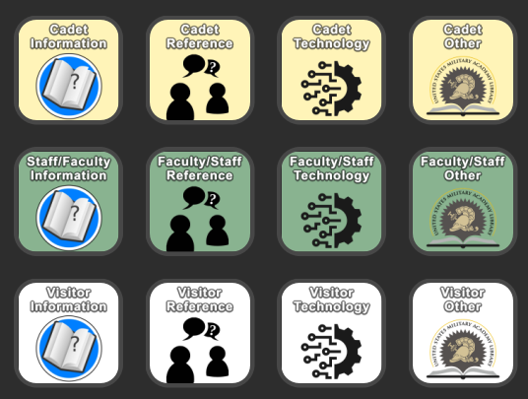
RefAnalytics, the system the USMA Library uses to track interactions allows users to create any parameters for data collection. As an added benefit, the READ Scale system for evaluating the amount of effort required to answer a patron question, was automatically included in our data collection system. To address the new data points we wanted to collect, the USMA Library reviewed data from the survey system and polled staff, finding that most interactions were short, 15 minutes or less. Findings also showed that requests were often simple, not requiring any significant amount of specialized knowledge, skills, or expertise. All submissions via the buttons were set to record transactions as 15 minutes or less and a level 1 on the READ Scale. Any button submission could be edited, so the USMA Library Staff could go in to add or edit the records of previous submissions to correct the data at any point.
Figure 3 shows the USMA Library’s current interaction submission form, containing the same data points that are either automatically recorded or manually entered via button on the Stream Deck. Fields for Support Type and Major Assignment are not included in the button options, with the expectation that the new button system supports a triage model. With the date, time, location, and staff information recorded with the press of a button, any longer interactions requiring added context or detail would be memorable enough that staff could edit the response to include further information when they had more time.
Fig. 3
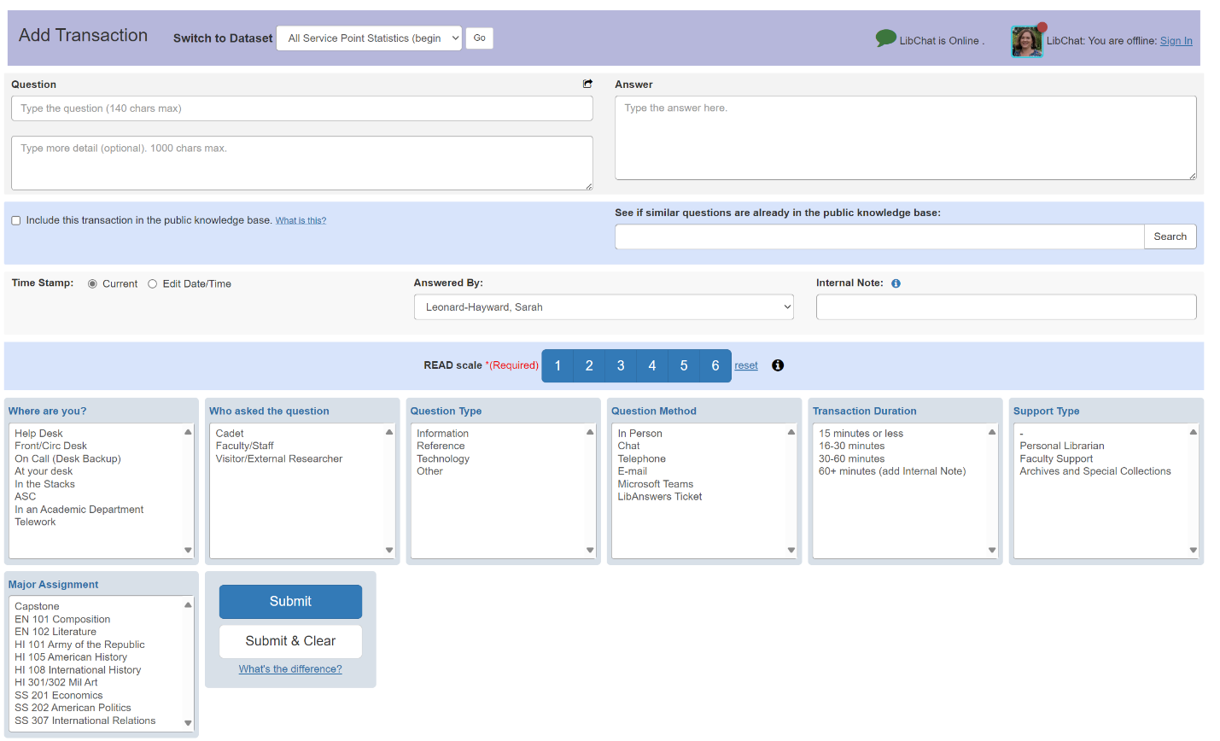

The functionality of the Stream Decks was based on designing a connection between the buttons and the data collection system. For USMA Library’s purposes, RefAnalytics had an API that could be used to connect other programs. The USMA Library used this API along with Power Automate to connect the individual buttons to the new survey form. A general outline of the commands can be seen on the next page in Figure 4.

Fig. 4
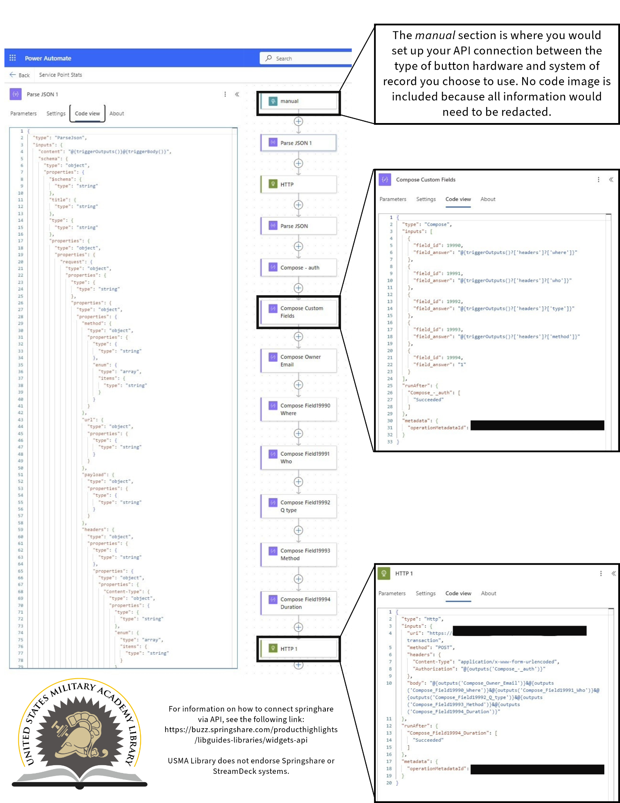

Figure 4 depicts the design the USMA Library used in Power Automate to connect the Stream Deck buttons to the various fields in RefAnalytics. These actions occur in the background in rapid succession. The first command manual can be opened to build the connection between the two systems through API. The next section compose custom fields shows the field id or the identification within the form expressing which field data will be entered into. For example, the field 1990 is linked to the header where. This expresses where data should be placed when a button is pushed. The final command HTTP 1 expresses what data needs to be pushed into the various fields.
Going back to our earlier example, when a button is pressed, the manual command ensures that the Stream Deck, Power Automate, and the RefAnalytics form can all be connected as a path for the data to navigate. Compose Custom Fields lays out the order in which responses will be recorded into the form. Each individual field is composed with answers associated with the submitters data, conforming to the fields in RefAnalytics. Finally, the HTTP 1 compiles the information and pushes it into the proper fields in the form. The entire automation process occurs in the background. Most library staff were never confronted with the design of the automation for the system.
It was not imperative that library staff know how the automation functioned, it was more important for the staff to know how to interact with the system and ensure records were kept as accurately as possible.
The various service desks provide support for distinct user needs. Once consistent terms and categories were determined, and automation was tested and functioning properly, library staff had to be educated on the definitions of the terminology used for each button in the new system. Instruction involved a staff meeting introducing the system and answering questions. A LibGuide was created, and laminated instruction diagrams were placed at each service point. One-on-one follow-up instruction followed as the Stream Deck system was added to each staff member’s work computer.
Fig. 5
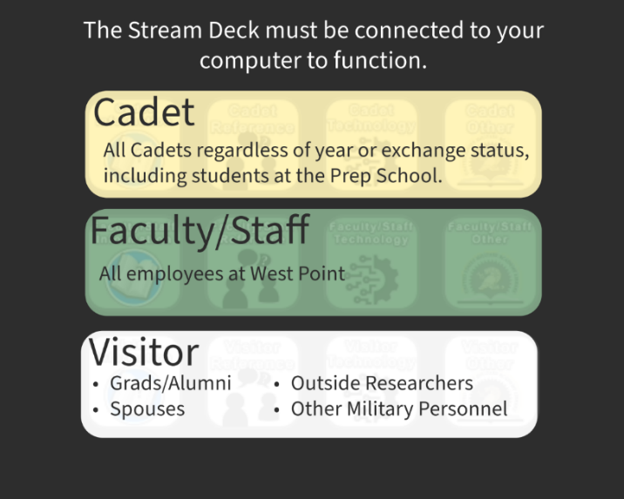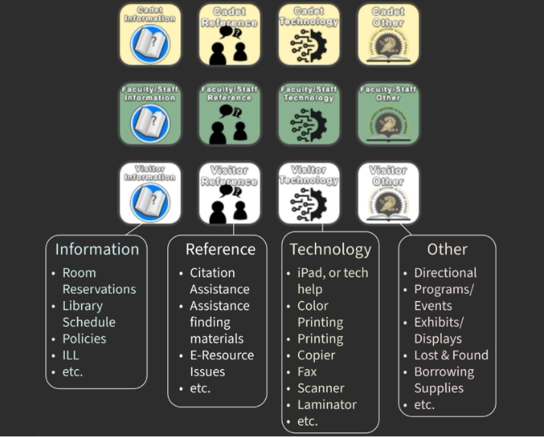
Figure 5 shows the instructions that were provided for staff, the portion in black was a visual diagram showing the buttons on the Stream Deck sorted into categories. Horizontally, the options included Cadet (for the top row in yellow), Faculty/Staff (for the center row in green), and Visitor (for the bottom row in white). The second diagram showed the organization of the buttons into vertical columns, Information (on the far left), Reference (center left), Technology (center right), and Other (far right). Each of the vertical columns also included lists of examples that would fall under each category.
Fig. 6
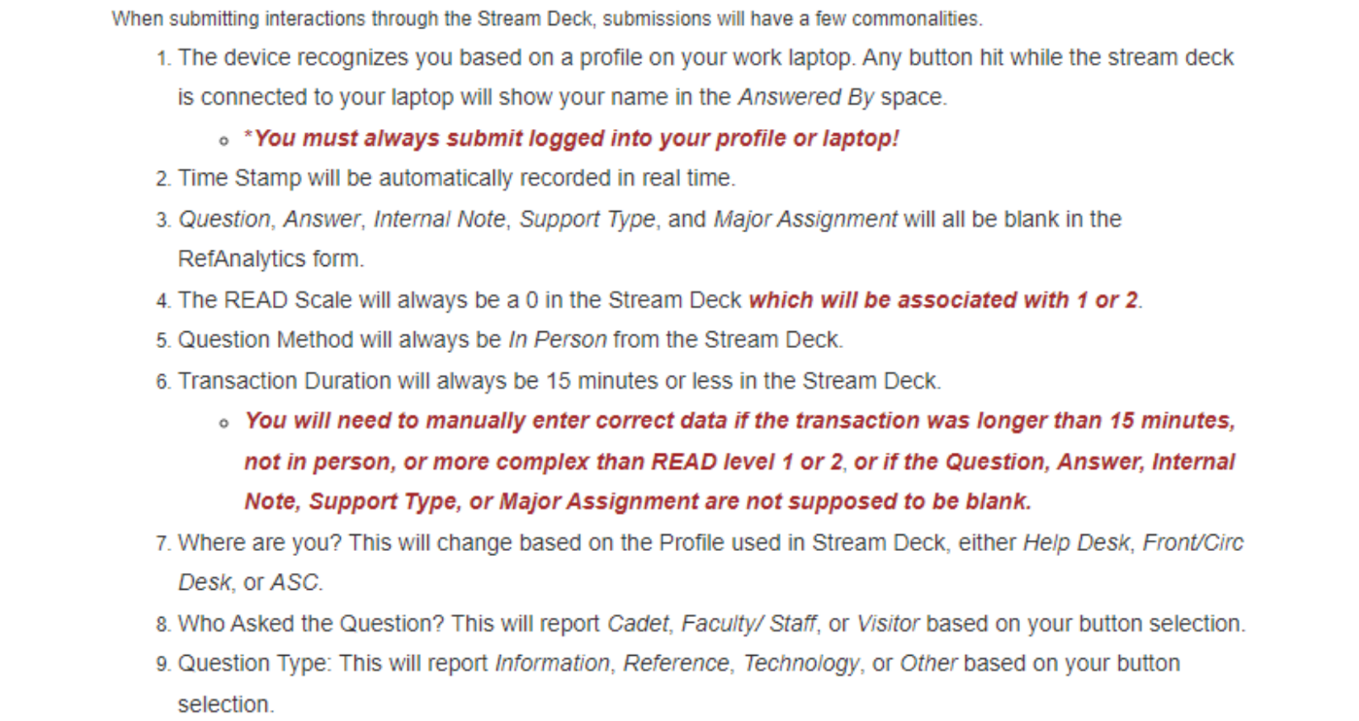
Figure 6 contains a portion of the instructional LibGuide with a description of how the system records various data points, along with reminders for staff to ensure data collection could be standardized amongst users.
Library staff were encouraged to provide feedback and request clarification or assistance with the Stream Deck systems whenever possible. Staff were also given the option to continue to fill out the form version within RefAnalytics if they were hesitant to adopt the new button system. An optional opinion survey was sent to staff in October 2024, responses were anonymous, and data was collected over one week, and 34% of staff answered the survey and provided comments. Findings from the survey were that 100% of respondents found the button system easy to use, 92% felt the button system was an efficient method for collecting transaction information, and100% said that the Stream Deck was reliable meaning no glitching or failures occurred. Out of 5 starts, the average rating was 4.69 and comments included:
- “Stream deck is preferred over the old survey system and/ or the manual LibAnswers entry.”
- “Easiest method of collecting data so far.”
- “i think it is efficient but unless we go in and add content we don't know what the stats are telling us. but then again we are not exactly overwhelmed with any on type of question anyway. Can we see the weekly or monthly numbers?”
- "The only problem is forgetting to use Stream Deck and remembering also that so many interactions with patrons are Stream Deck-able.”
- “great for capturing raw numbers, less efficient for the nuances of reference work”
“Love it! Would love an exhibits button to track who sees the exhibits on the 2nd floor.”
- “Makes it easy to enter encounters we have, and so I remember to do so much more frequently.”
The comments were mostly positive, specifically mentioning the ease of use for the button system. One commentor was concerned about seeing the data that was collected, all USMA Library staff have access to view the data collected via the button systems. Based on the comments received, a staff information session was held in December of 2024 to go over the comments and any concerns raised by staff after using the button system for a year.
The new method of reporting helped staff to access and edit submissions that come through via the buttons at various service points, allowing the date, time, and location of the transaction to be captured accurately. For USMA Library purposes, the editing option in the form also allowed staff to edit details about the Transaction Duration, difficulty level on the READ Scale, support type offered, the major assignment the question was affiliated with, and any other internal notes they deemed important to the records of the interaction. In effect, the button system resolved issues of time constraint at the various service points without sacrificing the data quality necessary for administration to make informed decisions based on service point data.

Results & Findings
The Stream Deck system was implemented at the start of the spring semester on January 2, 2024, providing time during the break between the fall and spring semesters for the USMA Library staff to learn the new system. Initial findings are visible when comparing data collected in 2023, through the old form, and 2024, through the new button system. Current reporting from the button system contains 9 months of data from January 2, 2024, through January 5, 2025. During this time frame, USMA Library recorded 10,964 interactions, 1,863 of those being reference. The same time frame in 2024 saw 8,062 interactions, 2,017 of which were reference. This shows an increase of 26.5% in total interactions recorded and a 7.6% decrease in the number of reference records.
Figure 7 depicts the total interactions reported annually at USMA Library between January 1, 2018, and January 5, 2025. The implementation of the button system has contributed to an increase in service point interaction records in recent years. Climbing from an average of nearly five thousand from 2018 through 2022 to over eight thousand in 2023 due to USMA Library’s efforts to create a culture of assessment. While initial efforts were effective at improving reporting, the increased use of reporting methods brought to light issues with efficiency. After implementation of the button system in January the USMA Library has 10,964 interaction records for 2024, doubling the reporting data from 2018-2022 and providing a significant increase over 2023.

Fig. 7
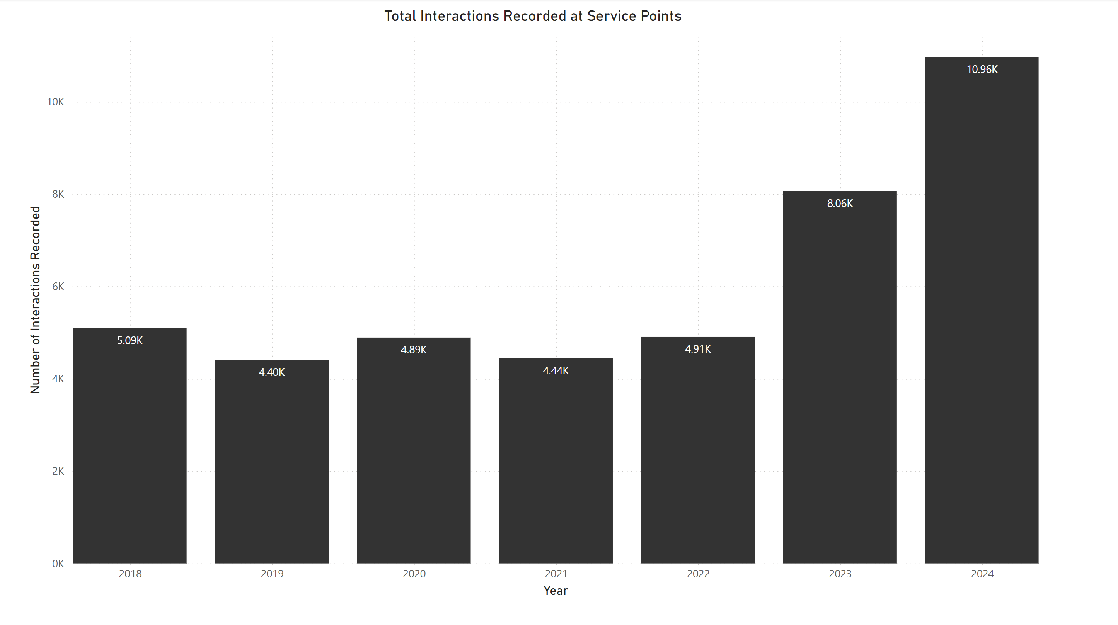
The USMA Library tracks usage by week. This provides administration with insight for staffing service desks. Figure 8 displays the number of interactions recorded per week with week number 0 indicating the week of January 1st and continuing to week 52 indicating the week of December 31st each year. The green dotted line depicts the reporting for 2024 showing a significant increase over previous years. The number of interactions reported rises or dips at various times linked to events in the academic calendar including breaks and large assignments from required courses.
Fig. 8
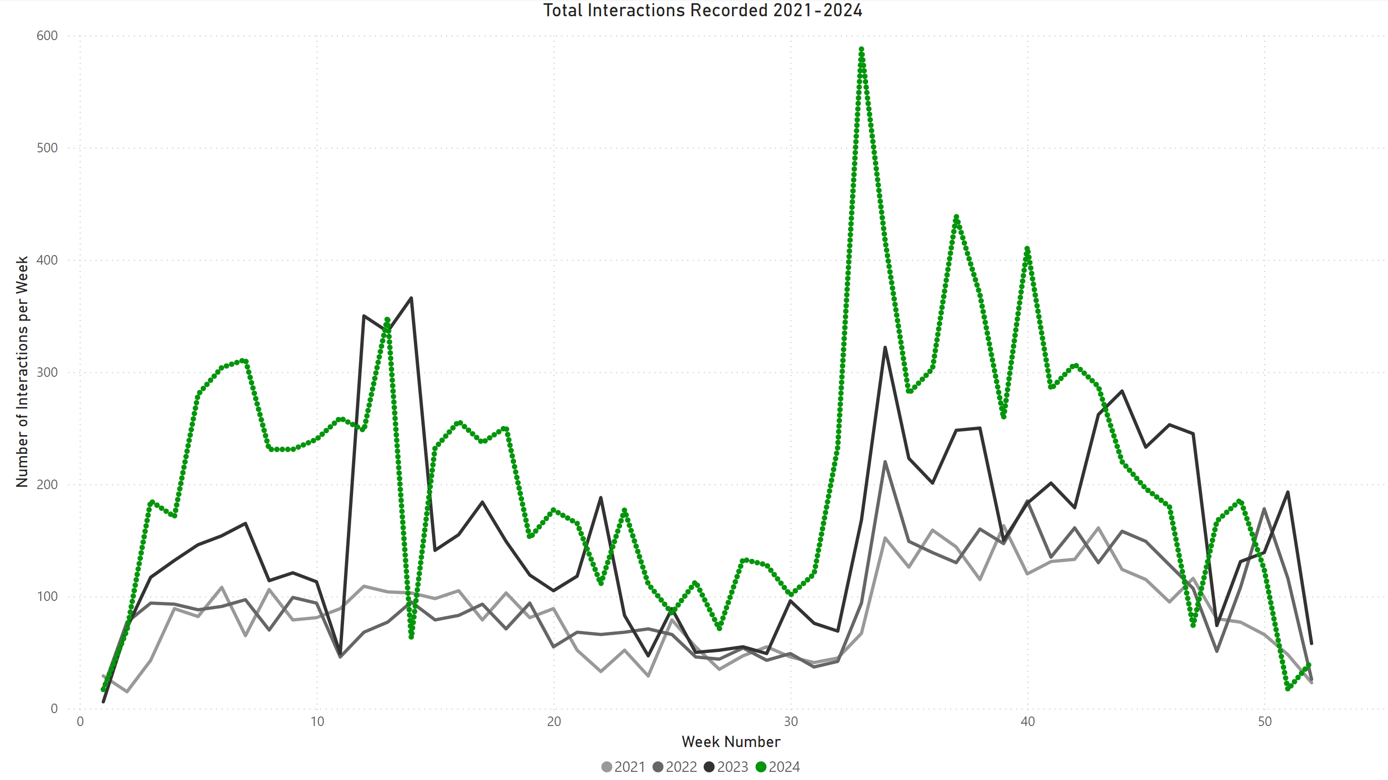
Monitoring and comparing the new data against historical records ensures some accuracy in the representation of activity in the USMA Library. Figure 9 contains individual pie charts for each year from 2021-2024. The size of the pie chart is indicative of the number of interactions recorded each year. The black slices indicate the number of reference interactions, and the gold slices indicate all other types of interactions that occurred each year (including information, technology, and other). As a profession, librarians are seeing fewer reference interactions due to technological advancements and self-service expectations of users. The data collected via the Stream Decks mirrors those expected changes over time.
Fig. 9
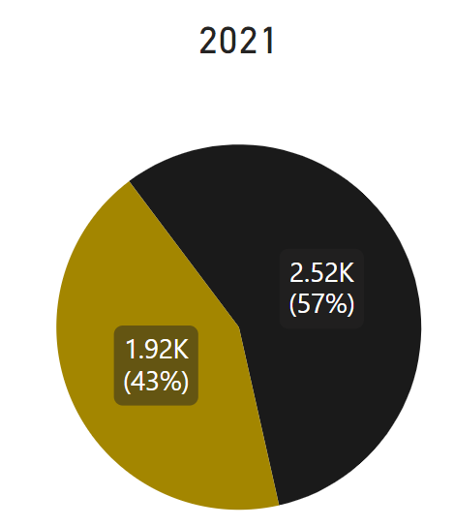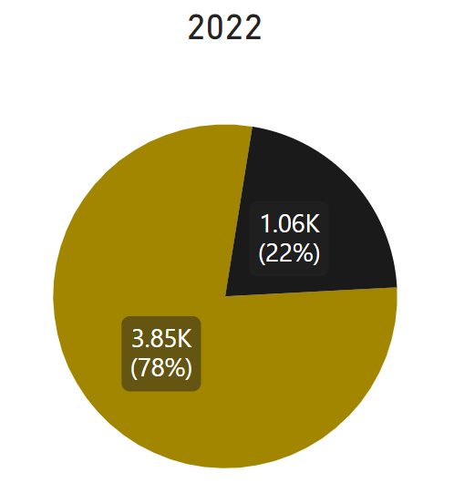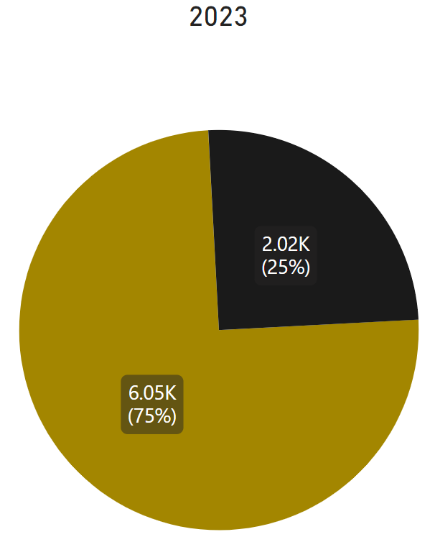

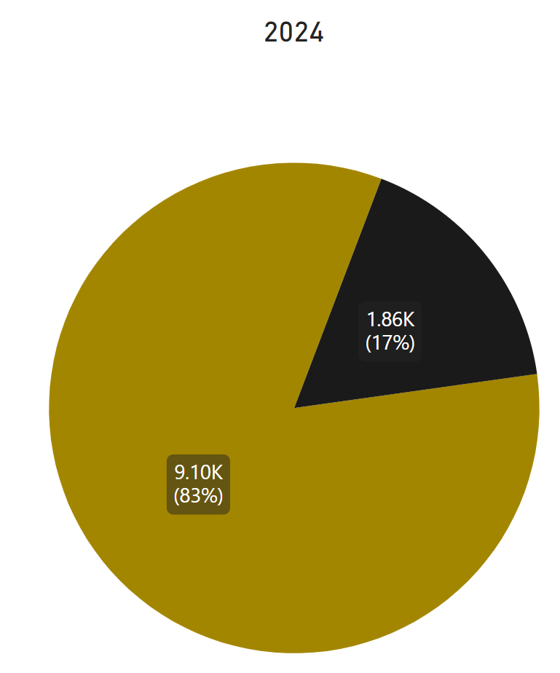
The drop in reference interactions is also visible via the chart in Figure 10. The USMA Library has had a steady decrease in reference interactions from 2018 onwards. While the drop in reference is important, the data shows an increase in interactions at service points overall.
Fig. 10
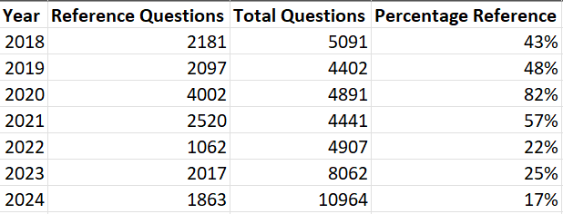
USMA Library staff were encouraged to provide feedback on the Stream Deck system, and positive results were quick to appear. Although some staff had been hesitant to adapt the new system, all staff chose to adopt the button within the first few months, noting that it was much more efficient and convenient to use. There was a huge increase in the speed of completing a record about a transaction. With our previous method, filling out the information required interacting with a questionnaire style form. Each submission took an average of three minutes and 52 seconds to complete. With the programmable button hardware, simple interactions are complete after the press of a button. The data processing in the background takes approximately five seconds to load through. Recording transactions with the new button system is over 45 times faster and still collected all the necessary data points.

Discussion
The most impactful findings were the benefits and efficiency of using the button system and the increased total reporting about interactions at all service points.
The records from the button system are more accurate because staff can quickly submit the record at the time of the interaction, rather than trying to remember the date, time, and details to fill out the reference analytics or data software form at a later time. In the previous system staff would track interactions mentally, with notes, or hash marks while at a service point and then enter the data when they returned to their office. This created a discrepancy in the times and dates reported. With programmable button hardware connected to reference analytics or data software, the recording of the transaction is completed in real time at the service points. At USMA Library, RefAnalytics contains the data and provides a useful Data/Time Stats tab where daily and hourly breakdowns of the questions received can be found.
The data collected in the analytics system is essential to expressing value and evaluating the services we provide our users. The button system will continue to be refined to fulfill the information needs and will provide insight to changes at service points over time. Additionally, findings will inform many of the decisions the USMA Library makes in the future, including decisions on scheduling at service points and better understanding the needs of our users.

Limitations and Opportunities for Future Research
The most obvious limitation in this study is the need for more data. The button system has only been used for about nine months, and only at the United States Military Academy. Having another library build their own programmable button system would provide insight into various use cases and allow for collective problem solving. The temporal issue will be assuaged over time as USMA Library continued to record data via the new button system.
Opportunities for future research include the application of programmable buttons for more in-depth tracking completed by student employees, technicians, or other library staff. With increasing pressure on library staffing and the need for all libraries to provide measurable value to their users, the triage model has become increasingly popular, requiring systems for tracking data that are intuitive, efficient, and easy to educate staff to use. Uniquely, at the USMA and other service academies, the students are also Active-Duty military personnel as laid out in U.S.C. §101(d) section 1. This means the USMA Library does not have any student employees. USMA Library is not equipped to study this technology for student assistants and other support staff who can be trained to use the system quickly, providing detailed results.
Additional opportunities include trying different technologies for all aspects of the triage automation system. The Stream Deck can be replaced with keyboards, macro pads, applications like SharpKeys or MacroDeck, and more. The automation coding USMA Library completed using Power Automate could have been done in Zapier, Make, or any other workflow automation platform. Finally, Springshare’s RefAnalytics system fit the needs of the USMA Library, but data could have been collected in a system as simple as excel, but there are a myriad of analytics systems that could be applied via commercial platforms like Gimlet or DeskStats. The general functionality of the triage system utilizing buttons to record interactions can be applied to systems that fit the needs of a specific institution.

Conclusion
Budgets are shrinking and libraries are challenged by the advent of AI and other advancements, it is imperative that libraries prove their value with data. The button system contributes to the overall body of work in library assessment because it integrates technological advancements with user experience and increased reporting needs. The greater Library Assessment Community can replicate these efforts and will be able to design systems that meet their own data needs to better support their individual missions.

Acknowledgements
The roll-out of the button system would not have been possible without the tireless efforts of the USMA Library staff including Travis Schaben – Associate Director for Systems, Chris Haraughty – Systems Librarian, O’Niesha McNiell – Systems Technician, and the cooperation of all USMA Library Staff members in adopting and applying this new technology.

Bibliography

Kamarck, Kristy. “Defense Primer: Military Service Academies.” Defense and Intelligence. Congressional Research Service, September 16, 2024. CRS.Congress.gov. https://crsreports.congress.gov/product/pdf/IF/IF11788.
Gossett, J. Gabe, Elizabeth Stephan, and Rebecca Marrall. “Implementing Reference Statistics Collection Software at Multiple Library Service Points.” New Library World 113, no. 5/6 (2012): 235–48. https://doi.org/10.1108/03074801211226328.
Thompson, Lawrence S. “History of the Measurement of Library Service.” The Library Quarterly: Information, Community, Policy 21, no. 2 (1951): 94–106.
Balay, Robertt, and Christine Andrew. “Use of the Reference Service in a Large Academic Library.” College & Research Libraries 36, no. 1 (January 1, 1975): 9–26. https://doi.org/10.5860/crl_36_01_9.
Balay, Robertt, and Christine Andrew. “Use of the Reference Service in a Large Academic Library.” College & Research Libraries 36, no. 1 (January 1, 1975): 9–26. https://doi.org/10.5860/crl_36_01_9.
Mosborg, Stella Frank. “Measuring Circulation Desk Activities Using a Random Alarm Mechanism.” College & Research Libraries 41, no. 5 (September 1, 1980): 437–48. https://doi.org/10.5860/crl_41_05_437.
Gossett, J. Gabe, Elizabeth Stephan, and Rebecca Marrall. “Implementing Reference Statistics Collection Software at Multiple Library Service Points.” New Library World 113, no. 5/6 (2012): 235–48. https://doi.org/10.1108/03074801211226328.
Lapidus, Mariana, Irena Bond, Erin Wentz, Samuel Bishop King, and Susan S. Mahnken. “Measuring the Quality of Reference Services Provided by Paraprofessionals at an Academic Library.” The Journal of Academic Librarianship 46, no. 5 (September 1, 2020): 102198. https://doi.org/10.1016/j.acalib.2020.102198.
Balay, Robertt, and Christine Andrew. “Use of the Reference Service in a Large Academic Library.” College & Research Libraries 36, no. 1 (January 1, 1975): 9–26. https://doi.org/10.5860/crl_36_01_9.
Mosborg, Stella Frank. “Measuring Circulation Desk Activities Using a Random Alarm Mechanism.” College & Research Libraries 41, no. 5 (September 1, 1980): 437–48. https://doi.org/10.5860/crl_41_05_437.
Balay, Robertt, and Christine Andrew. “Use of the Reference Service in a Large Academic Library.” College & Research Libraries 36, no. 1 (January 1, 1975): 9–26. https://doi.org/10.5860/crl_36_01_9.
Gossett, J. Gabe, Elizabeth Stephan, and Rebecca Marrall. “Implementing Reference Statistics Collection Software at Multiple Library Service Points.” New Library World 113, no. 5/6 (2012): 235–48. https://doi.org/10.1108/03074801211226328.
Gerlich, Bella Karr, and G. Lynn Berard. “Testing the Viability of the READ Scale (Reference Effort Assessment Data) ©: Qualitative Statistics for Academic Reference Services.” College & Research Libraries 71, no. 2 (March 1, 2010): 116–37. https://doi.org/10.5860/0710116.
Lapidus, Mariana, Irena Bond, Erin Wentz, Samuel Bishop King, and Susan S. Mahnken. “Measuring the Quality of Reference Services Provided by Paraprofessionals at an Academic Library.” The Journal of Academic Librarianship 46, no. 5 (September 1, 2020): 102198. https://doi.org/10.1016/j.acalib.2020.102198.
Kamarck, Kristy. “Defense Primer: Military Service Academies.” Defense and Intelligence. Congressional Research Service, September 16, 2024. CRS.Congress.gov. https://crsreports.congress.gov/product/pdf/IF/IF11788.
Singh, Tanveer. “What Is a Stream Deck and Should a Non-Gamer Buy One.” Make Tech Easier, November 22, 2023. https://www.maketecheasier.com/what-is-stream-deck/.
Lapidus, Mariana. “Not All Library Analytics Are Created Equal: LibAnswers to the Rescue!” Medical Reference Services Quarterly 38, no. 1 (January 2, 2019): 41–55. https://doi.org/10.1080/02763869.2019.1548892.

